**Crop Recommendation System – Documentation**

1. **Project Overview**

This Python project recommends the most suitable crop based on soil and environmental conditions provided by the user. The recommendation is derived from a CSV dataset using the closest match based on nutrient levels, temperature, humidity, pH, and rainfall. Each recommendation is stored in a MySQL database for record-keeping and analysis.

1. **Requirements**

**Python Packages:**

* mysql-connector-python
* Standard Python libraries: csv, math, os

**Software:**

* Python
* MySQL Server

1. **Code Explanation**

**A. load_csv_data(filename)**

Loads the dataset and converts values to appropriate types.

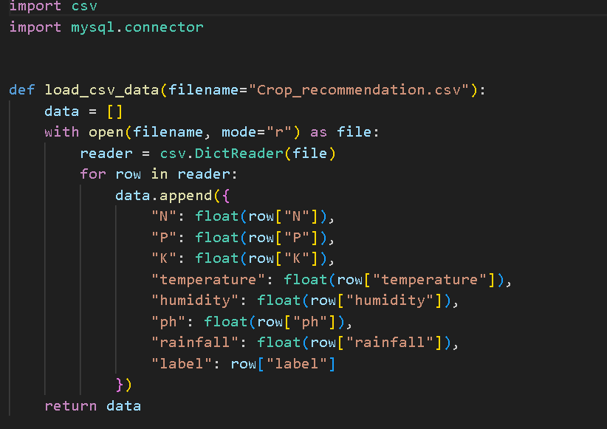

**B. recommend_crop(user_input, data)**

Compares user input to each row in the dataset using a distance metric and recommends the closest match.

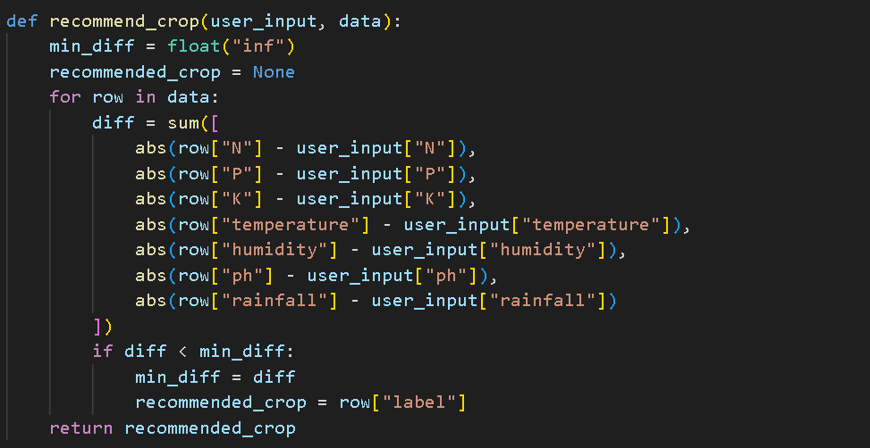

**C. save_to_mysql(user_input, recommendation)**

Saves the user input and the recommended crop into a MySQL table named recommendations.

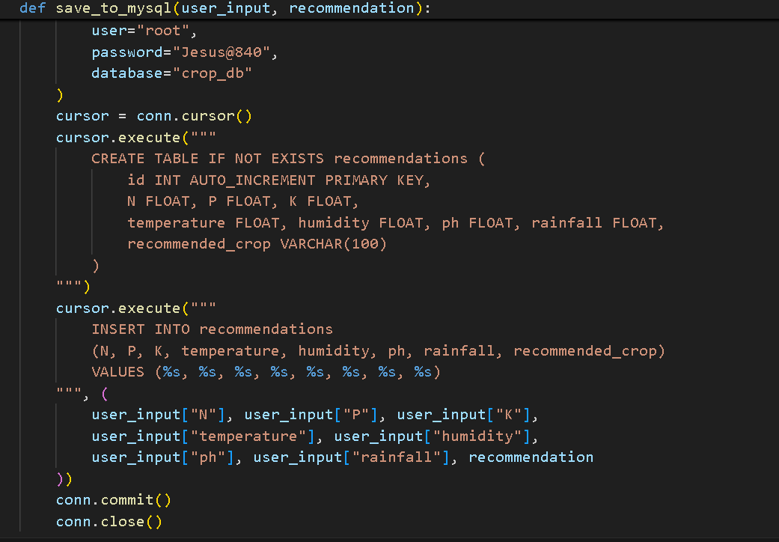

**D. get_user_input()**

Prompts the user to enter values for soil and weather parameters.

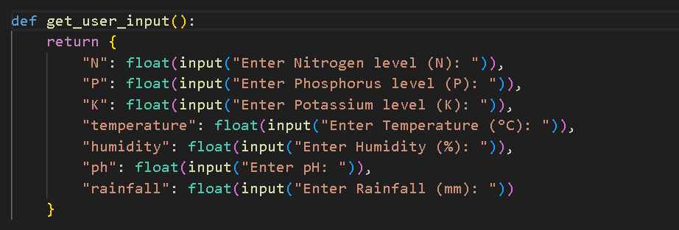

**E. main()**

Encompasses loading data, taking input, getting a recommendation, and saving the data.

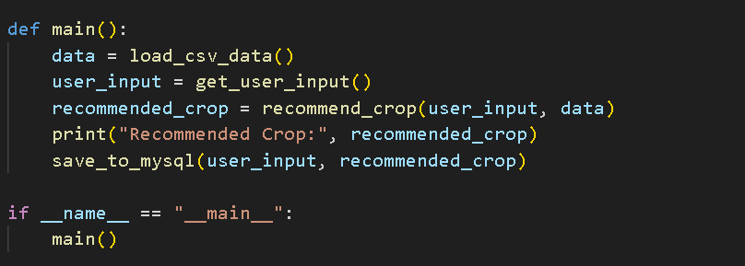

**F. fetch_recommendations()**

Connects to MySQL and displays all saved recommendations.

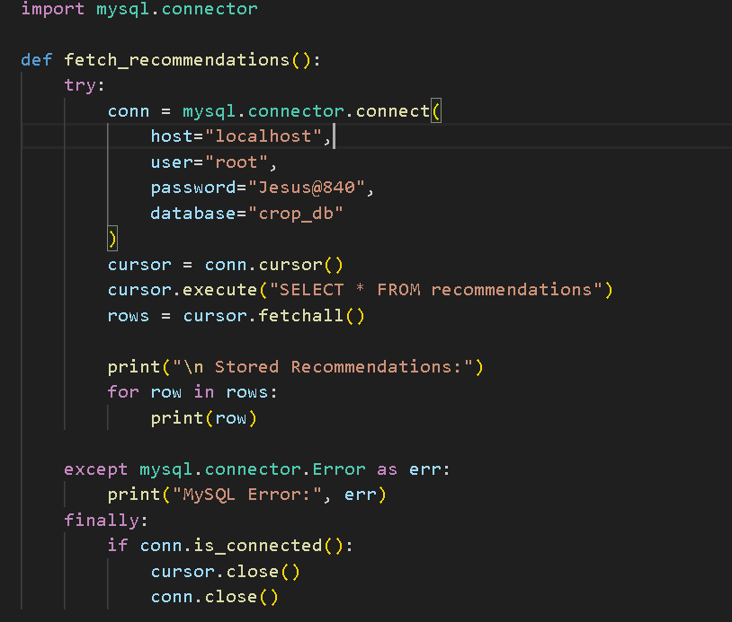

1. **MySQL Database Setup**

* Make sure MySQL server is running.
* Open MySQL command line or a GUI (like phpMyAdmin or MySQL Workbench).
* Create the database:

sql

CopyEdit

CREATE DATABASE crop_db;

The table recommendations is created automatically by the script if it doesn't exist.

1. **Sample Input & Output**

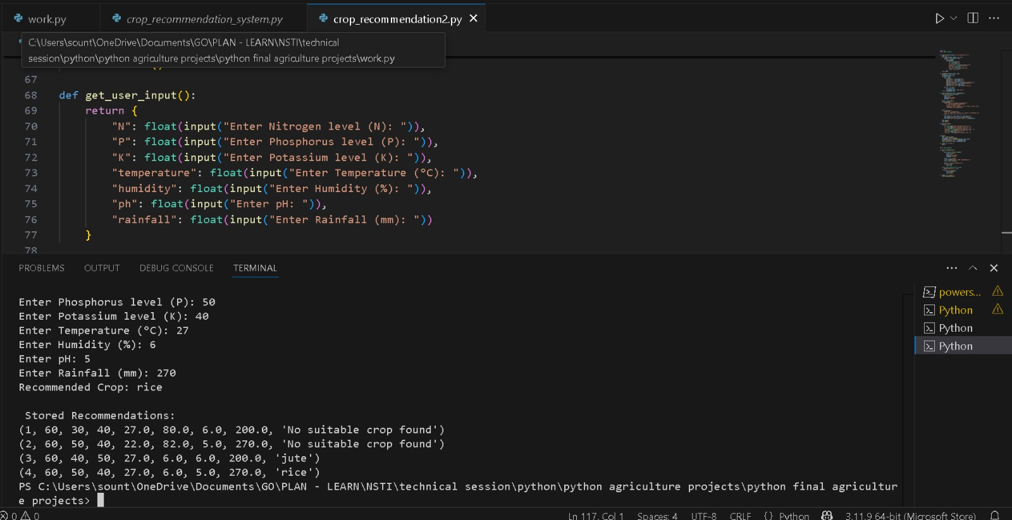

**Stored Record Example:**

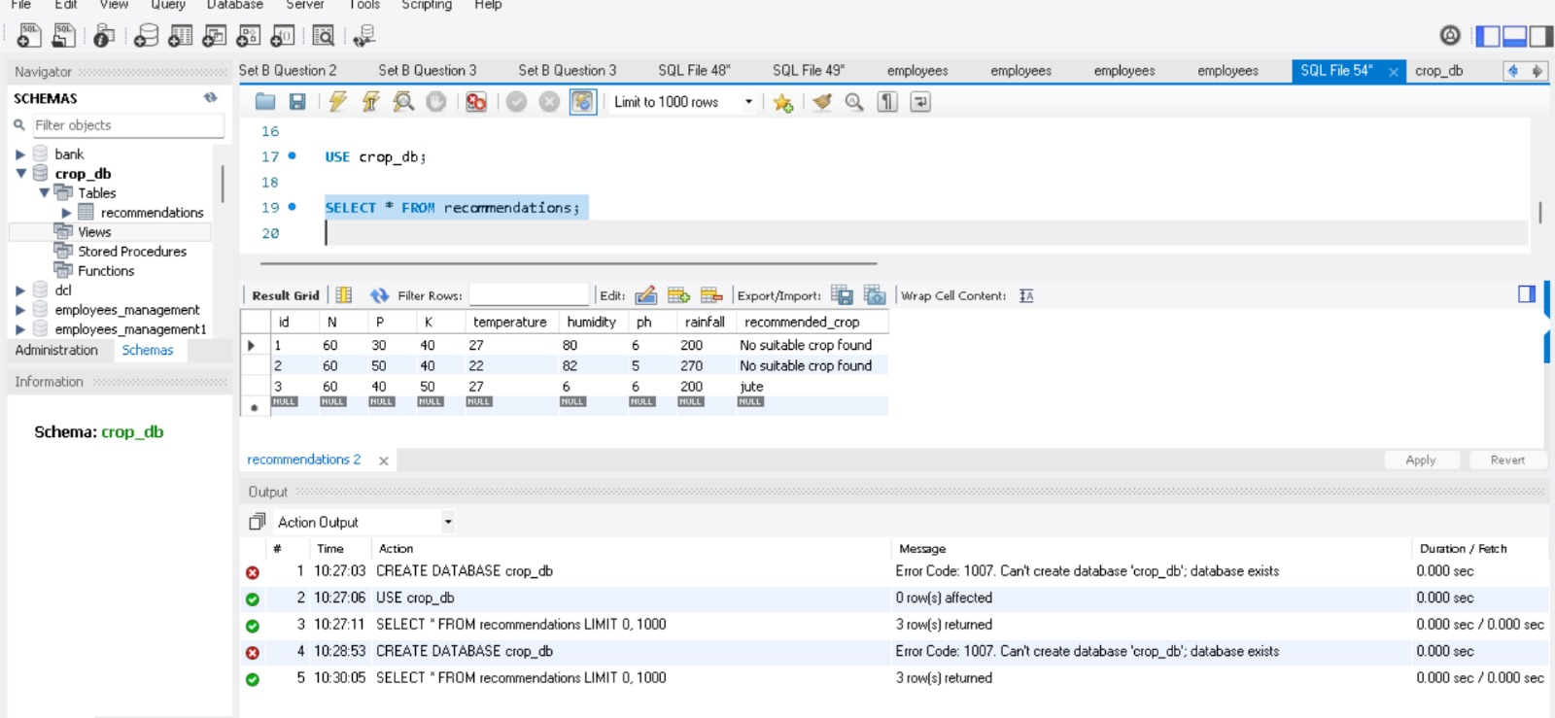

1. **Error Handling**

* MySQL errors are caught using try-except.
* Input values are cast with float() – invalid inputs will raise ValueError.
* Database connection is closed in the finally block to ensure clean exit.

**Tips**

* Make sure your Crop_recommendation.csv has the correct headers: N, P, K, temperature, humidity, ph, rainfall, label.
* You can extend this project using machine learning or by creating a web app interface.